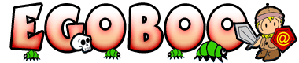
Version 2.7.8
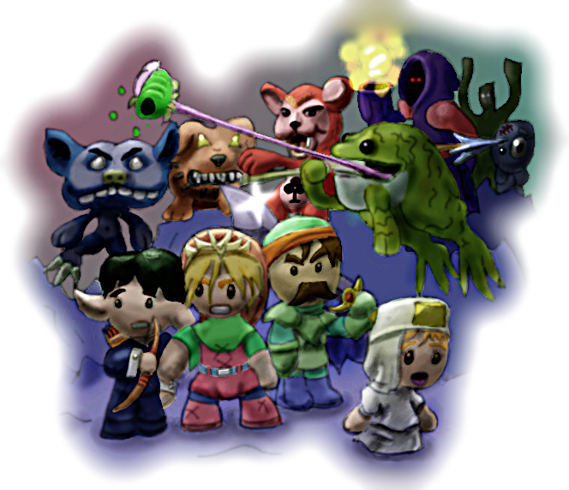
Game Manual
Manual by: Johan Jansen
Index
Installing the Game 3
System Minimum Requirements 3
Operating system 3
Troubleshooting 5
Starting a New Game 6
Which module should I pick? 6
Secret modules 6
Loading and Saving 7
Death 8
Hero Classes 9
Game Settings 10
Changing the controls 11
Sound Settings 11
Video Settings 11
GAME OPTIONS 13
Player Display 14
Leveling up 15
Status Effects 15
World of Egoboo 18
Development Credits 22
Support and Contact 26

Installing the Game

System Minimum Requirements
These are the minimum we know it works on, but it might very well work on less. Tune down some graphical effects if your frame rate is low.
Processor: Pentium III/Athlon with 2.0 GHz or more
Memory: 256 MB RAM (512MB RAM Recommended)
Video: Any graphical 128 mb GFX card supporting OpenGL 2.0 or better
Sound: Any sound card will do.
Multiplayer: For Hotseat, Egoboo requires gamepads, joysticks or a connected mouse. Internet or LAN/UDP is currently not supported.

Operating system
Egoboo runs under Windows, Linux and Macintosh. Here is a guide how to get the game to work under each operating system:

Windows
Windows users simply run the installer and install the game to a directory of your choice. Simply run Egoboo.exe to start the game. All required software to run the game should be included and automatically installed along with the game. The game has been tested and runs fine under Windows 95, Windows 98, Windows 2000, Windows XP, Windows Vista (with compatibility mode) and Windows 7.

Linux
To get Egoboo to run on Linux, you first need to compile the binary.
Step 1: Make sure you have these packages, and if you don't install them: * libsdl-image1.2-dev * libsdl-mixer1.2-dev * libsdl1.2-dev * libsdl-ttf2.0-dev
* build-essential
Step 2: Extract the source code.
* Either use a graphical interface or type: tar -xzf egoboo-<version>.tar.gz
Step 3: Open a console (or terminal) and cd to the game directory in the main egoboo folder.
* cd ~/egoboo-<version>/game (Assuming that the directory is in your home folder)
Step 4: Compile the source.
* make -f Makefile.unix
Step 5: Install Egoboo. Type:
* cp egoboo ..
Step 6: Start Egoboo!
* Type 'cd ~/egoboo-<version> && ./egoboo'.
* Enjoy!
Note: You will have to do step 6 every time you want to run Egoboo
Macintosh
To get Egoboo to run on Macintosh, you will first need to compile the binary.

Step 1:
You will need:
- A Mac (of course!) - It should compile on both PowerPC and Intel Macs, but it has only been tested on Intel Macs.
- Mac OS X 10.4 (Tiger) or later
- XCode (You can find it on the Mac OS X DVD) - It has been tested with XCode 2.4 and 2.5; I don't know if it will work with an earlier version.
- The following frameworks:
- SDL 1.2 or later (from http://libsdl.org/download-1.2.php )
- SDL_image 1.2 or later (from http://libsdl.org/projects/SDL_image/ )
- SDL_mixer 1.2 or later (from http://libsdl.org/projects/SDL_mixer/ )
- SDL_ttf 2.0 or later (from http://libsdl.org/projects/SDL_ttf/ )
These should be installed into /Library/Frameworks. If the Frameworks folder doesn't exist, create it.
- The Egoboo source distribution (2.6.9 or later)

Step 2:
Extract the Egoboo source code, and open the "osx" folder inside, then open "Egoboo.xcodeproj".

Step 3:
Make sure the active build configuration is set to "Release" (Project->Set Active Build Configuration->Release), and click "Build and Go".

Troubleshooting
If you have problems installing or playing the game, do not hesitate to contact us on the game forums at http://egoboo.sourceforge.net/forum

There are some general things you can do first that may fix your problems:
- Make sure your computer has the minimum system requirements listed above
- Update your hardware drivers to the newest version available.
- Check out if there is a newer version of Egoboo available. Many bugs are fixed each release and your problem may very well be already fixed! New releases are announced at http://egoboo.sourceforge.net

Starting a New Game
To begin play as a new character, simply click the Start New game button in the Main Menu screen. The menu will now list all available Starter Modules. Each character class has its own Starter module, which is a single level with a quest to get you used to the character's abilities and skills. When you beat a module, your character and his or her inventories are automatically saved (Remember to pick up any items you want to keep before finishing the starter module). You can also skip the starter modules and play the pre-made characters available in the Load Game screen.

Which module should I pick?
Every module has a different class. You can play as a Soldier, a mighty warrior and adept in the arts of combat. Or you can play the Elf, an agile and skilled archer who can use magic, or you might prefer the Adventurer - the jack of all trades. The first quest for your new character is described in the module description you see upon the module selection screen. Each module is also rated with a difficulty rating, rated in stars. The more stars a module has, the more difficult it is to beat. We recommend playing either the Soldier or the Adventurer for new players.

Secret modules
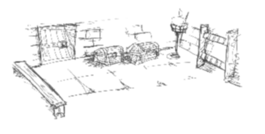
There are many secret classes that can be unlocked by completing special quests, challenges or finding secrets. For example if you save the imprisoned G'nome in the Rogue Starter and make him escape alive, you will unlock the G'nome class! The other classes are for you to find and unlock.

Loading and Saving

Loading a game
To continue playing a previous character, simply press Load Game in the main menu screen. You can then select which player(s) you want to play. All your characters from your beaten starter modules and any pre-made characters should be listed there. You can select multiple players to play Hotseat, but that will require you to have a working joystick, mouse or gamepad connected. Know that certain modules can only be played single player and will not appear in Hotseat mode.

After selecting the character(s) you want to play, a module selection screen appears. At first there will only be few modules shown here. But later on in the game as you progress in the game story, tenfolds of modules will be unlocked!

Saving your game
Any progress you have made with your character along with your inventory will be saved when you have beaten a module. Press escape to bring up the in-game menu and a option Save and Quit will appear if you have beaten the module. To beat a module you usually have to accomplish a specific task, such as killing a boss monster, finding a magic item or saving some NPC's. Town and City modules always save upon exit. Note that character progress is saved individually. If you unlock a level with one of your characters, the same module is not always unlocked for your other characters!

Note: Laster on in the game you can acquire pets who are loyal helpers. You have to pick up those pets and keep them in your hands or inventory to save them along with your character. If not, your pet will forever be lost!

Death
You will probably die at some point in your travels, but don't worry! Death is usually not the end in Egoboo! You will never lose your character permanently. Most modules allow you to respawn after death, but doing so comes with a price. In the default difficulty setting, you permanently lose 15% of your total experience and money, as well as any in-hand items and keys. You also drop some money in addition to the money you lose permanently, but that money can be picked up again.

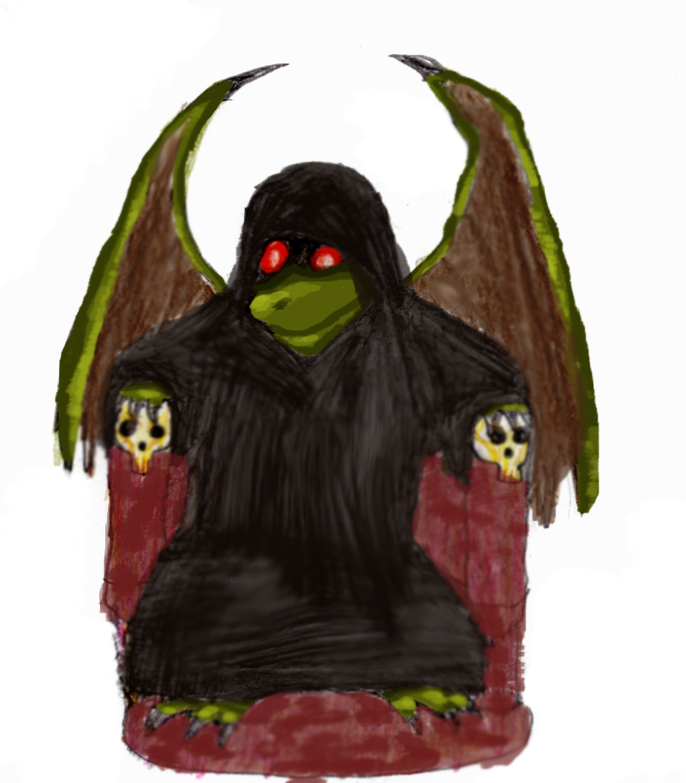
In multiplayer games, carry Scrolls of Rebirth or join up with a Healer to avoid these bad effects (Being resurrected does not result in death penalties loss!). Note that in Hard mode, all respawning is disabled! (You can still resurrect through magic though). In single player it is smart to carry more life potions.

Hero Classes
Egoboo 2.7.4 introduced the first Hero Class into the game. The Hero class system is a way for characters to evolve into new, more specialized classes. Hero classes usually allow you to retain your previous skills and abilities, but will forever change your future skills and how your abilities evolve from now on.

Becoming an Archmage for example, will turn you into a fearsome powerhouse of the arcane. It allows access to a whole new level of magic – Spell Orbs. These are much more powerful and rare than Spell Books, they cannot be bought in any shop. But becoming an Archmage is very difficult and tiresome process. Only the most devoted and determined arcane spell users will ever become Archmages. In exchange for great power, the Archmage is frail and physically weak.

There are other Hero classes to be added, but it is your job to find each of them and do whatever is necessary to become one. Know that turning into a Hero Class is usually only available at higher levels later in the game (usually around level 6 or so) and that the transformation is permanent!
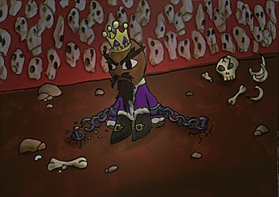

Game Settings

General Keys
These are default keys and cannot be changed.
- Escape opens the in-game menu
- 1, 2, 3, and 4 give character stats (Holding SHIFT, CONTROL or ALT while pressing a number button displays more detailed information)
- SPACE is used to respawn if you have died
- F11 makes a screen shot

Default Keys for Keyboard
Arrow keys move the character
SPACE makes your character jump

T use left hand items
G drop or grab left hand item
B rotate right hand inventory

Y use right hand item
H drop or grab right hand item
N rotate right hand inventory

5 and 6 rotates the camera
+ and - zoom the camera

Changing the controls
You can simply change the input controls for the keyboard, mouse or gamepads through the Input Settings menu. In the main menu, simply click the Options button to find the Input Settings menu.

Sound Settings
This section describes what all the sound options do.
In this menu you can enable or disable sound and music or change the volume of either.
SOUND CHANNELS: This specifies the maximum number of sounds that can be played simultaneously.
BUFFER SIZE: Default is 2048. Only change this if you hear stuttering in your sound effects.
HIGH SOUND QUALITY: This will allow high quality sounds to be fully loaded into memory. This might make some sounds better but reduces performance.

Video Settings
This section describes what all the video options do.
SHADOWS: Off, Normal or Best. This setting determines how good the in-game shadows look.
TEXTURE FILTERING: This option sets which kind of texture filtering you want to use. Unfiltered being the fastest and ugliest option while Trilinear 2 being the best and most performance heavy option. If your video card supports it, there is an Anisotropic option which is the absolute best filtering mode.
REFLECTIONS: Off, Low, Normal or High. Determines how good reflections look in-game. Low enables character reflections, while Normal also enables particle reflections. High adds reflection fadeout. Off disables all reflections.
ANTIALIASING: Off or X1 to X4. Anti aliasing makes everything in the game look sharper and minimizes distortion artifacts. This option is performance heavy and can be repeated 1 to 4 times (four being best and most performance heavy).
DITHERING: Enables or disables dithering. This can make textures smoother on low color bit settings.
FULLSCREEN: Enables or disable full screen. Requires a restart to take effect.
Z-BIT: The z-bit buffer. Higher number is better.
MAX LIGHTS: Determines the maximum number of dynamic lights. If your frame rate isn't too slow, set this to a high number.
3D EFFECTS: This option will increase 3D quality and enable special 3D effects.
GOOD WATER: Allows multilayer water and makes water quality much better.
MAX PARTICLES: Sets the maximum limit of particle effects in the game. Increase this to a high number make certain special effects such as spell or explosions look better.
RESOLUTION: Changes the game resolution. You can specify wide-screen resolutions manually in setup.txt (located in the Egoboo folder).
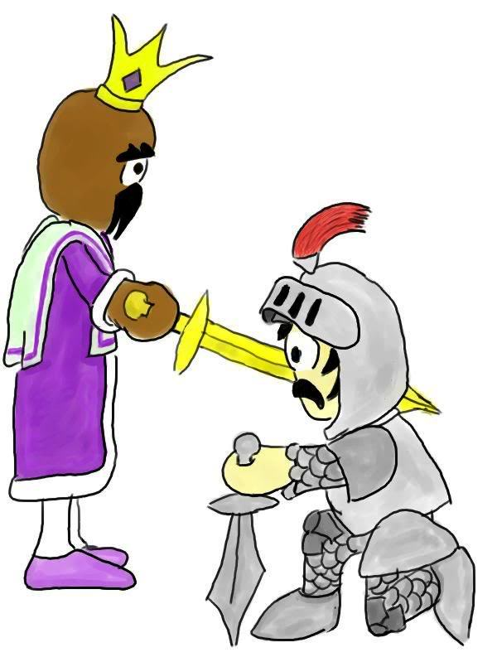

GAME OPTIONS
General game settings are covered in this section. Most important on this screen is the difficulty setting which can affect your game play a lot.
GAME DIFFICULTY: This will affect certain aspects of the game. Note that Hard mode will also give a 20% XP bonus and Normal a 10% bonus to XP while in Easy mode you gain no XP bonus and you cannot unlock the final level! Certain puzzles and bosses can get harder/easier depending on difficulty. The effects of every difficulty are described below the button.
MAX MESSAGES: The maximum number of messages to be displayed on the screen.
MESSAGE DURATION: This determines how long messages are displayed before they disappear.
AUTOTURN CAMERA: Enables or disables that the camera rotates automatically when the player moves around. If set to Fast, the camera will rotate left if the player moves left and rotate right if the player moves to the right.
DISPLAY FPS: Hides or shows the current Frames Per Second count.

Player Display
Each player has a little portrait on the right side of the screen, with one or two status bars below it and two more little pictures to the left and right. The character's name (abbreviated) and money (Zorkmids) is located above the portrait. The portrait itself indicates the your physical appearance and armor. The image to the left of the portrait shows the current item your left hand, while the right image is your right hand. The red status bar is your life. When this bar is empty, your character dies. The other bar is usually mana, the magical energy of your character. Mana comes back with time, but impatient folk drink mana potions. If your status bars change color, it means something is unusual. For example, the life bar may change to green if you are poisoned.
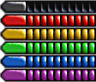
Dead


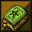
Life Character portrait
Divine Mana
Poison Left hand Right hand
Special Effect
Arcane Mana

While playing you can press 1, 2, 3 or 4 to display detailed character stats for your characters. Each character has a Strength, Wisdom, Intelligence and Dexterity score that determines the effect and outcome of various tasks.

STR - Directly adds bonus damage to most melee weapons, unarmed attacks and
longbows. You need 21 strength to use the Maul of the Titans. Increases chance
to correctly block an attack with an shield.
WIS - Reduces chances of poisoning self. Increases damage/effect of all Divine
spells. Reduces damage taken from arcane spells. Increases resistance vs.
Bind spell. Increases chance to find hidden bottoms in chests.
INT - Required to read specific scripts and identify special items. Increases damage
dealt and control for all Arcane spells. Reduces damage from divine spells.
Slightly increases reload time for gunpowder weapons.
DEX - Increases aim for ranged weapons and spells. Increases attack speed with all
weapons. Increases chance to sneak. Adds bonus damage to backstabs.
DEF - Every point of defense adds about 0,4% damage reduction. Someone with 70 DEF
reduces all damage taken by about 27% (After applying damage resistances)

Leveling up
There are various ways of gaining experience. Some ways are more effective for certain classes than others. Soldiers gain extra when killing stuff, rogues gain when opening chests, wizards when casting a unknown spell while the Healer gains extra when an ally kills a monster. When you gain enough experience, your character will increase in level. Every level gain increases the basic stats mentioned above in addition to some extra Life. Spell casters gain more Mana. Your level also determines how powerful spells you can cast. The maximum level you can reach is 20.

Some classes gain special abilities when leveling up. Scoring critical hits, seeing in the dark or becoming invisible are a few examples. Every class have different skills that they gain at various levels. Certain abilities also improves further with each gained level
after gaining the skill in the first place (duration, chance, power, etc.)

Status Effects
There are different types of afflictions a character can have in Egoboo other than normal hit point damage. Many are caused by special powers or spells These effects are described below in detail:

Burning
Some fiery effects can set a character on fire. A character that is on fire will take continually small amounts of fire damage. Examples are the fire ball or a dragons breath weapon. The Restoration spell or soaking yourself in water will usually kill the fire.

Dazed
This is type of confusion from some sort of impact and causes difficult and uncontrolled movement. Examples are the Meteor spell or the Whip weapon. A restoration spell or a skillful character applying a Medkit can heal this affliction.

Energy Drain
Energy Drain lowers your max life and is usually permanent! Examples on creatures that cause this are the Ghosts and Vampires. Life lost this way can be restored trough the Restoration spell and is replenished automatically when you complete a module or when you respawn.

Frozen
Some cold effects renders creatures frozen. This slows or completely stops their movement speed in addition to lowering dexterity, armor and jump power. Duration and effect varies and usually stacks. An example that causes this condition is the Frost Nova spell. Restoration removes this effect.

Grogged
A type of confusion from wooziness in the mind. An example is the confusion spell. A restoration spell or a skillful character applying a Medkit can heal this affliction. A creature that is both dazed and grogged is in big trouble...

Invisible
A creature that is invisible cannot be seen by other creatures unless they have a special ability that allows them to do so. Invisible creatures can move past or attack other creatures without losing their invisibility. Some creatures have this special ability and invisibility can also be gained from the Unseen spell. Only the Truesight spell or a similar effect let's characters see invisible. Know that there are many invisible treasure chests hidden around in various dungeons!

Kursed
Items that are kursed cannot be dropped or unequipped. In addition they usually also give some negative effect to it’s holder. Creatures that are kursed by some spell effect or trap gain lot of different penalties on their stats. Only a Restoration or Identify spell can rid a character of a Kurse. Very skillful characters can even use Medkits to remove Kurses!

Panicked
This condition only applies to monsters and NPC's. Sometimes creatures get panicked for some reason. This may because of some spell, poor morale (Team-mates or boss killed for example), because of it's natural fears (Trolls fear fire and vampires holy for example) or lastly it may just be cowardice. Creatures that are feared run away and ignores everyone else for a period of time. Some creatures may regain their courage when a new leader arrives, they are healed or when backup arrives.

Paralysis
This status indicates that the player or creature affected cannot move their hands
and/or the rest of their body (Depending on strength of the effect). Examples are
the Fright monster or the Bind spell. Disenchant or Restoration can dispel this effect.

Poisoned
Poison constantly saps away the victims life points until the duration runs out or the victim dies. Amount of damage and duration depends on the strength of the poison and it's source. Poison always stacks. Examples are the Tranch monster or poisoned weapons. Healing effects or Restoration removes poison.

World of Egoboo

The worldmap of Egoboo is called "Lorule". This world is inhabited by many monsters, races and mystic and magical items inhabited. Big cities of humans, giants in the mountains, D'warfs digging for gems, gold and mithrill deep in their mines. Egoboo is a large world to explore and many a danger lurks around every corner. Will you be the hero who destroys the evil Dracolich and saves the king? Or will you, like many others fall?
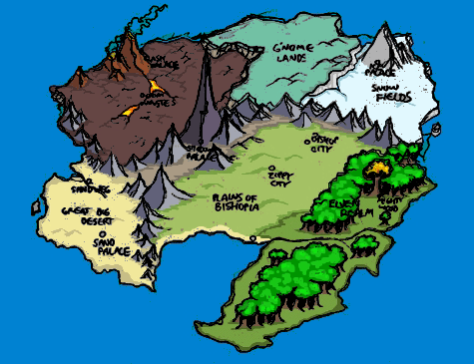
LORULE

Plains
Bishopia proper is located in the lush green central plains. It is populated mostly by humans. There is a thriving seafaring community along the southern coast. Many port towns, as well as pirates, can be found along the coast. The plains are a docile area for the most part. Many farms and small villages dot the landscape. There are a few cases of wandering lumpkins around the countryside. Occasionally, an adventurer can stumble across one of their lairs.
Also to be found in the plains are old abandoned castles and wizard towers that have been overrun by various beasties. The willing adventurer can find some quick treasure, and the occasional magic item.
Bishopia, which lies near the Northern center of the plains region, is the seat of power for King Bishop. King Bishop is the latest ruler in a long line of nobles. Recently the lands of the continent were unified under King Bishops rule. There are still some hostilities among the various lands though, old differences do not die down easily. Many different races and people have things to gain from King Bishop's abduction.
In King Bishop's absence, the Arch Bishop of Bishopia has used the authority of the church to lead the continent until such time as the King is safely returned.

Elven Woods
The Elven Woods can be a tranquil place. However, during recent times of turmoil, even the Elven Woods are not entirely immune from evil. The Elf King, Laureatriel Swiftbow has long been a friend of King Bishop. In recent years a band of elves, know as the Dimlock Elves, have been vying for the crown of the Elf King. The Dimlock Elves would have much to gain from King Bishop's abduction. Laureatriel Swiftbow would not be able to call on Bishopia's armies for support if there were a Dimlock uprising during this time of turmoil.
The Dimlock Elves have long preferred living in caves rather than trees. Though not on friendly terms with other elves, the different elves tolerated each other until recently. Often trading would occur between the Dimlock and other tribes. Trade has now been cut off as the Dimlock Elves closed the door on the outside world. It is rumoured that the Dimlocks have turned to evil ways.
The heart of the Elven Realm is at Mighty Wood, the oldest and largest tree in the world is there. Around the Mighty Wood is held council of all the woodland creatures. Elves, Dryads, Treants and others meet in peace and harmony in this most sacred of places. All are sworn to commit no malice to each other in this place. Thus is peace kept here, if not in the rest of the world.

Icy Lands
The icy expanse of the Snow Fields can be a hazardous place for the unwary hero. Giant ice creatures haunt these lands. The only friends one might find are a few scattered villages of Vikings and G'nomes. In the heart of these frozen lands lies the Ice Palace, wherein is located one of the Sporks of Power.
The southern, more populated region of the Snow Fields is known as the Northerlands. The peoples of this area relish a good fight. Watch your back in the taverns and inns.

G'nome Lands
G'nome technology fills the cities and mines in this otherwise desolate land. Although the surface may seem rather bare, the underground is lush with precious metals and gems. Along the Western border of the G'nome Lands lays an escarpment. At the bottom of this cliff are the hot and barren Doom Wastes.
The hills and valleys of the G'nome lands hide bands of Cobols, Trolls and Lumpkins.

Doom Wastes
Beware the Doom Wastes. Nothing lives is these volcanic lands but Evil. The few human inhabitants are strong and weary of strangers. Occasionally you may find guilds of wizards in these lands, researching some spell no doubt. Magic is strong in these wastes, as is the presence of Demonic forces.
Lava creatures issue forth from streams of magma. Undead animate and rally forth in search of the living. Deep in the bowels of the Doom Wastes, the Ash Palace hides it's treasure; one of the Sporks of Power.

Great Big Desert
Dry and desolate, the Great Big Desert is the home to many poisonous snakes and insects. The sand nomads that live here welcome strangers with open arms. Often you may find yourself in a harem. More often you may find yourself as lunch for a pack of jackals. Beware the Sandwhich.
The primary export of this region is sand. Often you will stumble across sand mines in your journeys. Watch out for sand traps on your journey. Be on the lookout for the Sand Palace, the home of one of the Sporks of Power.

Stone Mountains
Many treasures, as well as many dangers await you in the Stone Mountains. This range of mountains runs across the length of the continent of Bishopia. Just to the west of center lies the tallest peak in Bishopia, Skully Mountain. Atop Skully Mountain is the Shadow Palace, where you will find one of the Sporks of Power.
The peoples of the Stone Mountains are a sturdy lot, comprised of both human and G'nome. The G'nome in this region mix up a hearty snack called G'Ranola, it provides all the energy one might need to climb a mountain.
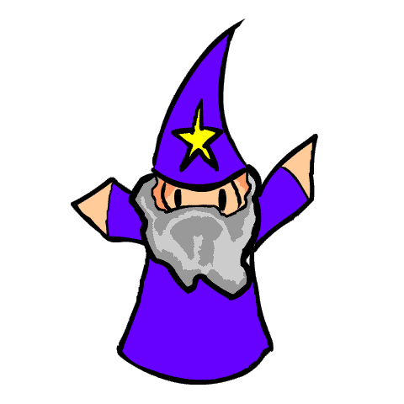

Development Credits
ORIGINAL GAME DESIGNERS
Aaron Bishop aka Programmer X
Benjamin Bishop
LEAD DESIGNER
Johan Jansen aka Zefz
PREVIOUS LEAD DESIGNER
Alazimir
LEAD CODERS
Ben Birdsey
Jonathan Fischer
CODING
Arakon
Aleous
Johan Jansen aka Zefz
OPENGL PORTERS
Morgan Aldridge
Nicholas Vining
Ted Milker
Daniel Burrows
Gary Clark
Ollipekka Makitalo
Germain Sauv
Francisco Mu aka Paco
Merlin Avery
Dan Olson
William Tan Heok Wee
Ryan Thompson
Matt Adam
Christophe Beauregards
Christian Laforte

LEVEL DESIGN
Johan Jansen aka Zefz
Florian Natterer aka Clonkinator
PurpleSquerkle
ModBaker Map Editor
Xenom[GER]

SOUND AND VOICE
Aleous
Mycorf
Johan Jansen aka Zefz
Leviticus
MUSIC
Klastek Timrak
Edward Blakely aka eddyster
MODELLING
Johan Jansen aka Zefz
John Dick aka Booger
Ben Weiss aka Cimeries aka Chainsaw aka "That damn kid".
Ben Birdsey
Ptapasu
Icezd
ARTWORK
Kalle Suhonen aka Woodmouse
Ben Weiss aka Cimeries aka Chainsaw
Hiroy
John Dick aka Booger
Benjamin Birdsey aka bgbirdsey
PurpleSquerkle
LINUX SUPPORT
Hans de Goede
Penguinflyer5234
MACINTOSH SUPPORT
Ben Urban
Jonathan Fischer
WEBSITE DESIGNER
PurpleSquerkle
LEAD BETA TESTER
Florian Natterer aka Clonkinator
Johan Jansen aka Zefz
BETA TESTERS
Benjamin Birdsey aka bgbirdsey
HyugaNeji
Ben Weiss aka Cimeries aka Chainsaw
Ben Urban
penguinflyer5234
penguinflyer2222
Alex aka Maxaxle
Feenfleisch
Kalle Suhonen aka woodmouse
PurpleSquerkle
SPECIAL THANKS TO
Arne Kristian Jansen aka Aigle
eatsonlyheads
Golem
Veiva
Agent of Dread (Have a cookie!)
Freegamer
Denis Jaimes
And all you others out there who have helped
contribute to this wonderful game!

And special thanks for the support from the Sourceforge team!
OLD ZIPPY EGOBOO TEAM
LEAD DESIGNER ZIPPY EGOBOO
Matty Noble aka Elmin
CODING
Arakon
Paul Müller aka bitnapper
Aleous
ARTWORK
Hunna
Spyro
AiletheAlien
MODELLING
Iceczd
Graham Lackey aka Grey Jakal
booger
Pteromys
LEVEL DESIGN
Johan Jansen aka Zefz
John Dick aka Booger
Pteromys
EGOMAP DESIGNER
Arakon
THANKS TO
Goldenbeast
Sneakeye
Gargoyle
MR?
eatsonlyheads
Klohnish B aka pinkelephant
Barnaby-James Astles
Adam Chamberlin
Mike Holt
ioquan

Support and Contact

We highly recommend you to join the Egoboo Community forums! Egoboo development is still active and we welcome all help we can get. Developing Egoboo is very easy and there are a lot of tools and tutorials out there. Give it a shot!

Official Egoboo website: http://egoboo.sourceforge.net/
Egoboo Community forum: http://egoboo.sourceforge.net/forum/
IRC Chat Channel: irc://chat.freenode.net/#egoboo
Contact the lead Designer: zefzsoftwares@hotmail.com
EgoWiki: http://egoboo.wiki.sourceforge.net/

Download the Development Package
The DEV bundle contains tons of unfinished or yet-to-be-added new objects, levels, classes, artwork and development tools. Download the development package here:
http://sourceforge.net/projects/egoboo/files/Development%20Extras/ego_dev277.7z

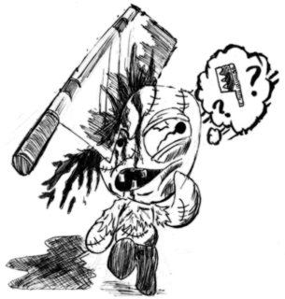
The current latest DEV bundle is III. But DEV bundle IV is almost ready for release! Many of the tools in the DEV bundle contain Windows Binaries, but all the game content in there are to use by any platform.

